**Question 1:**

public class PrintName {

public static void main(String[] args) {

for (int i = 0; i < 10; i++)

System.out.println("Abdul Shabbir");

}

}

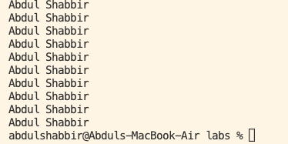

**Question 2:**

import java.util.Scanner;

public class PrintOddNumbers {

public static void main(String[] args) {

Scanner input = new Scanner(System.in);

System.out.print("Enter the value of n: ");

int n = input.nextInt();

input.close();

if (n < 1) {

System.out.println("Sorry you must enter a positive integer.");

return;

}

int sum = 0;

for (int i = 1; i <= n; i += 2) {

System.out.println(i);

sum += i;

}

System.out.println("Sum is: " + sum);

}

}

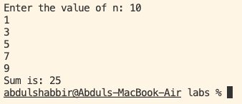

**Question 3:**

import java.util.Scanner;

public class PrintMultiplicationTable {

public static void main(String[] args) {

Scanner input = new Scanner(System.in);

System.out.print("\nPlease enter an integer: ");

int x = input.nextInt();

input.close();

System.out.println("\nMultiples for the number " + x + ":");

for (int i = 1; i <= 10; i++) {

System.out.println(i * x);

}

}

}

